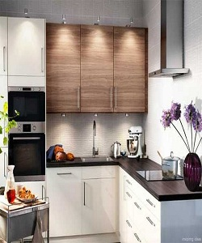

Lexington Kitchen Cabinet

$219.08

Availability: In stock

Description

Modern small kitchen interior design cabinets. The smooth-surfaced doors are custom made to your kitchen project, and are available in a range of sheen levels, colors and wood grain textures. Certified for the highest quality.